Short desc of artworks

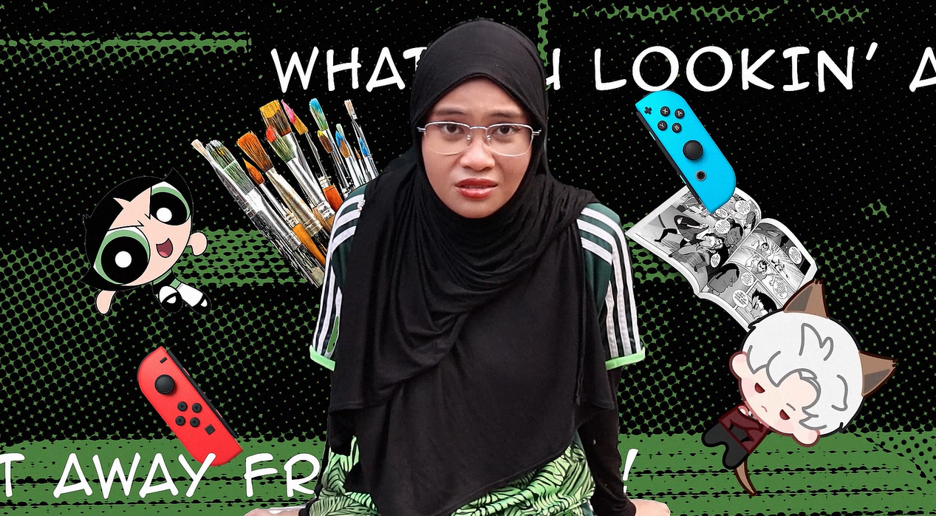

1. The Tri-B’s (Video)

* This is an assignment for Digital-Post Production subject where we have to do a self-introduction video. The theme of this video is Y2K and PowerPuff Girls inspired aesthetic. Hence, this was a video that relies on effects like posterize time in order to give the early 2000s impression. Edited on Adobe After Effects.
* Link : <https://drive.google.com/file/d/1b6M507rxgfjdcR7HMYSb5LQNFhwXH0zD/view?usp=sharing>

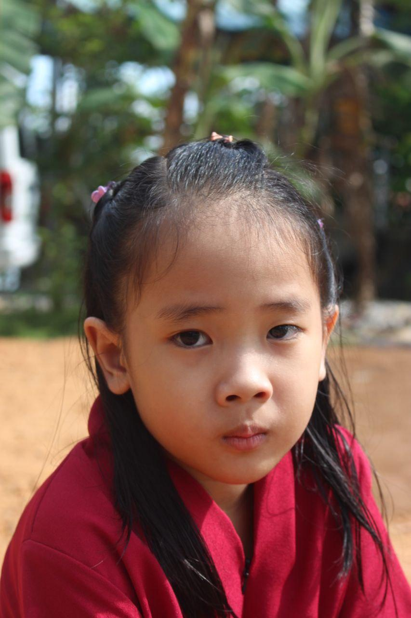

1. Inara

* One of my many attempts in photography. This is a portrait of my dearest little sister, Inara. This portrait was taken around April 2024 on Canon EOS 15.

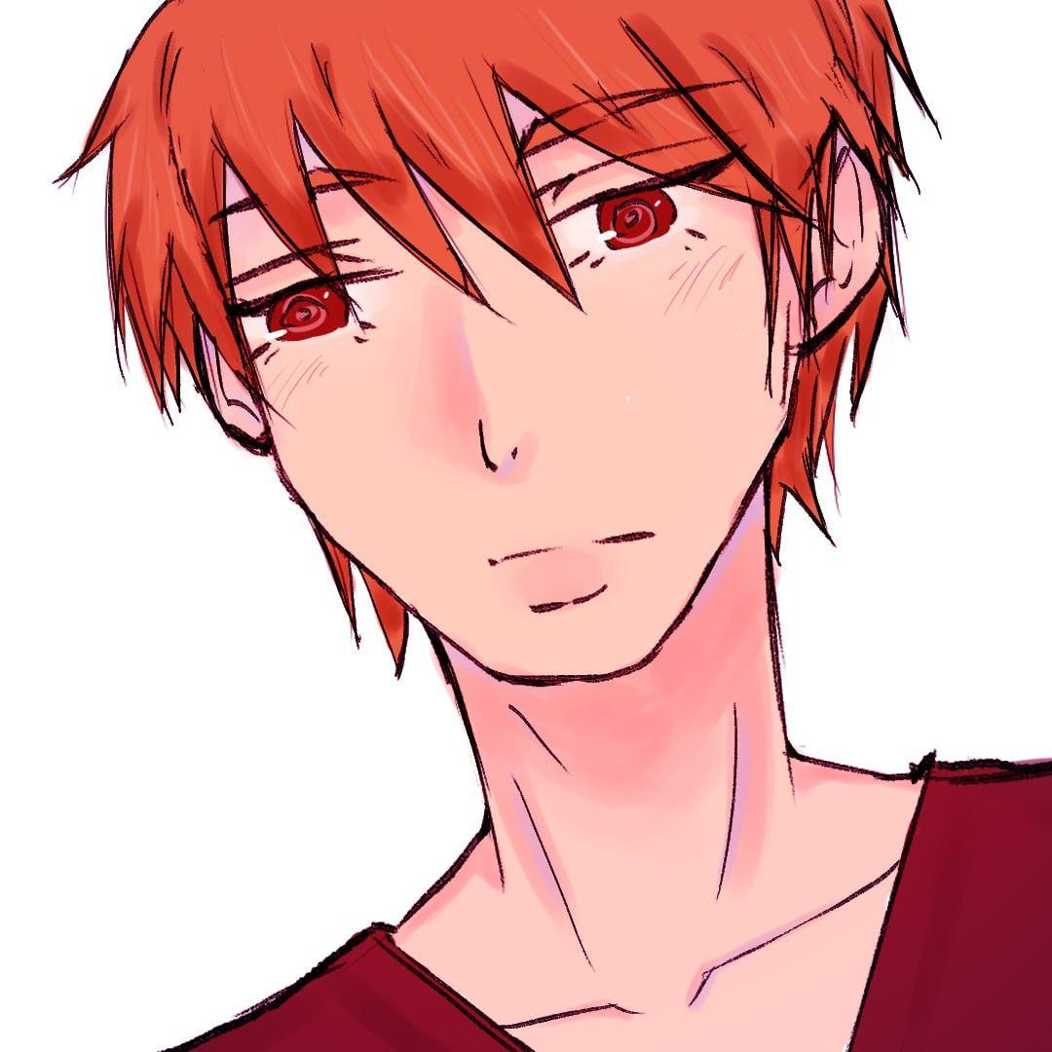

3. Sohma Kyo fanart

* A simple fanart of my favourite character from Fruits Basket, his name is Sohma Kyo.



4. Curious Cat

* One of my attempts at designing a campaign poster. The theme was Education & Literacy, thus I chose curiosity as some sort of sub-theme. Poster designed on Adobe Illustrator.

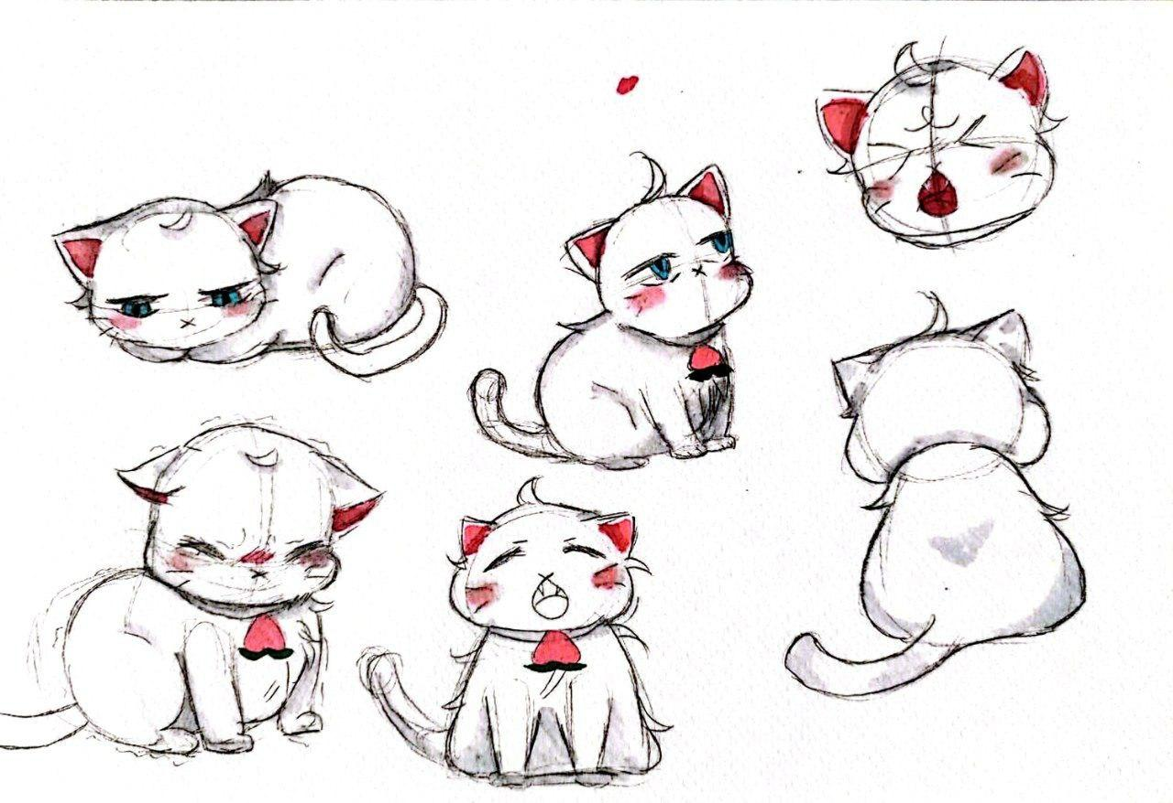

5. Hakutou fanart

* A fanart of my favorite character in “My New Boss is Goofy” <3 I love how fluffy, expressive yet tsundere he is !

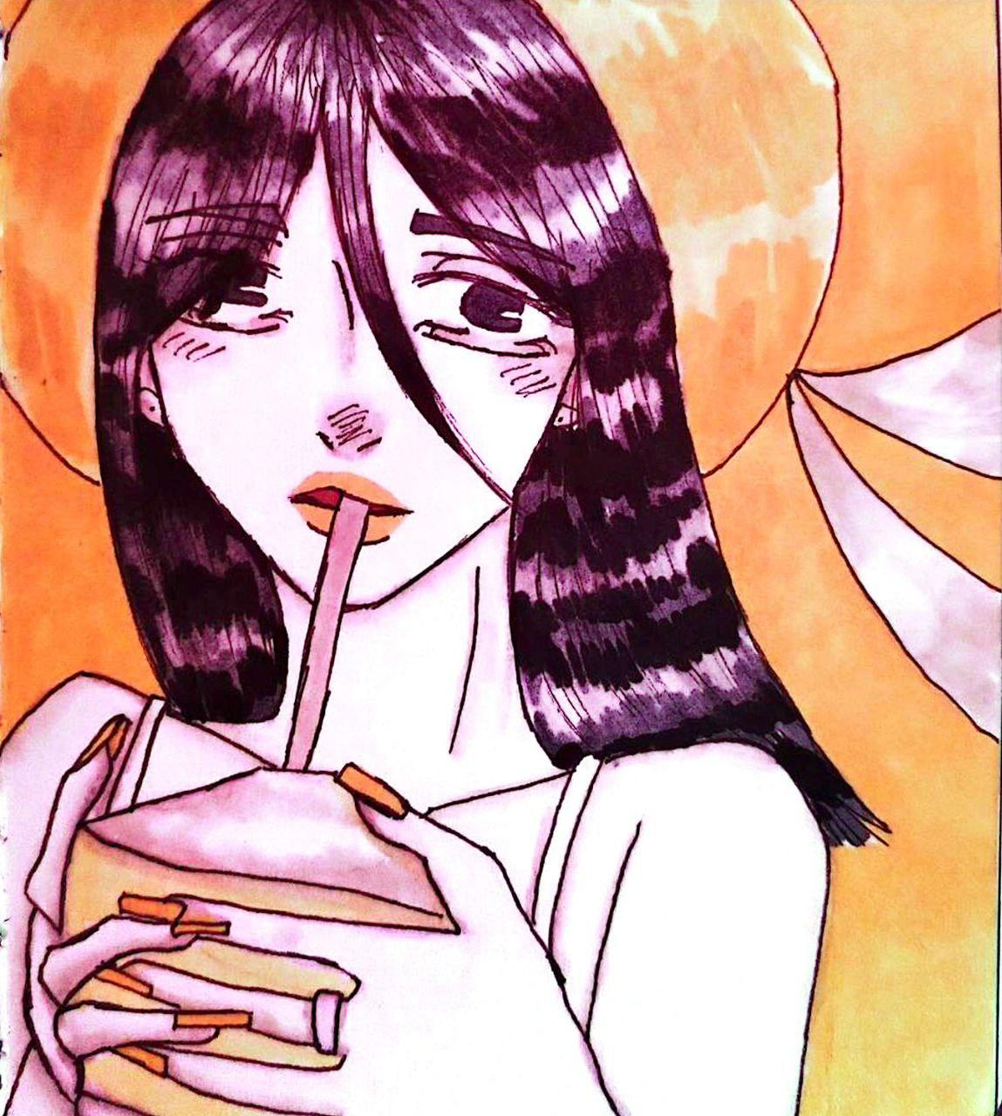

6. Summer GIrl

* A simple piece of art that I’m proud of. This was one of my artworks with alcohol markers. I use the brand Ohuhu.

Favourite Quote

* *You didn’t go through all that for nothing -***unknown**

Short bio

* I’m Izzah, a 22-year-old young lass wandering in creative fields. Yes, wandering. I barely call myself an artist because I just can’t figure out what I really love to do and truly good at. However, I love art regardless of its form which is why I have multiple artsy talents like drawing, painting, editing and crocheting. I even love to be a model or an actress if I have the chance! Yes! Even if I’m not good at it lol. As for my personality, I described myself as assertive and reliable but I’m also clueless and often having trouble receiving information. Aside from creative hobbies, I love reading comics(mostly manhwas), games (persona is my fav series) and watching cat videos.

Socmed

Email - [izzahbatrisyia987@gmail.com](mailto:izzahbatrisyia987@gmail.com)

Ig - @/dizzy.co8 (art) @/infxnity.rtx (editing)